Name : MUHAMMAD MUBASHAR ALI
Student ID : BSIET02213012
Subject: Object Oriented Programming
Lab: 11
Example # 01

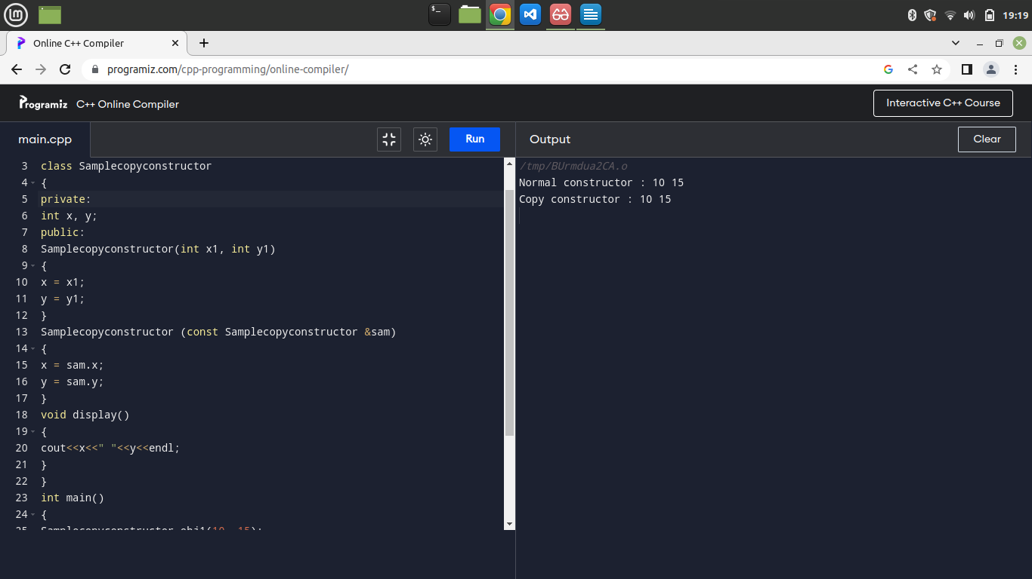
Example # 02

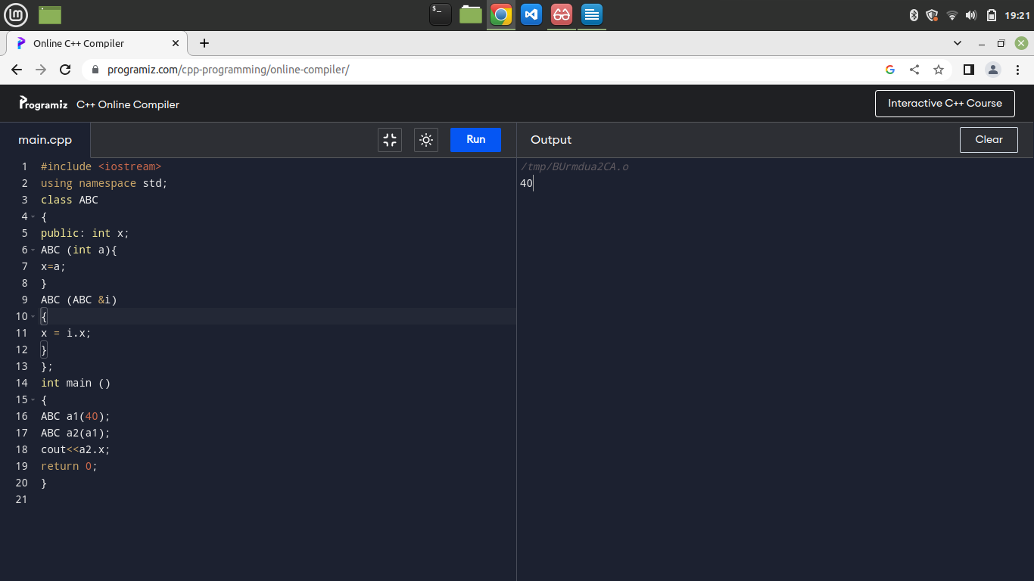
Example # 03

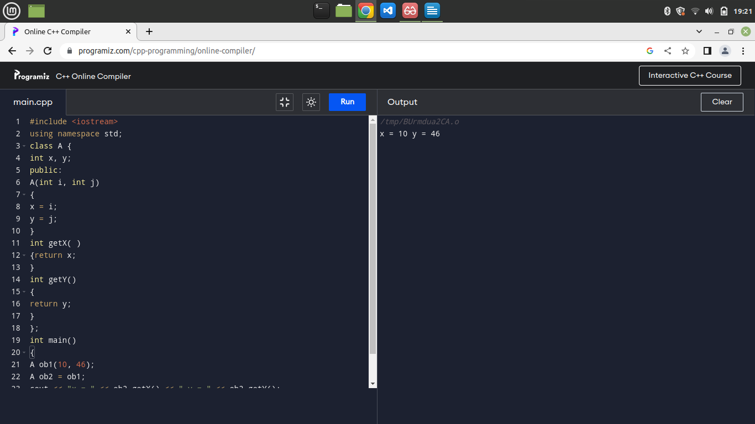
Example# 04

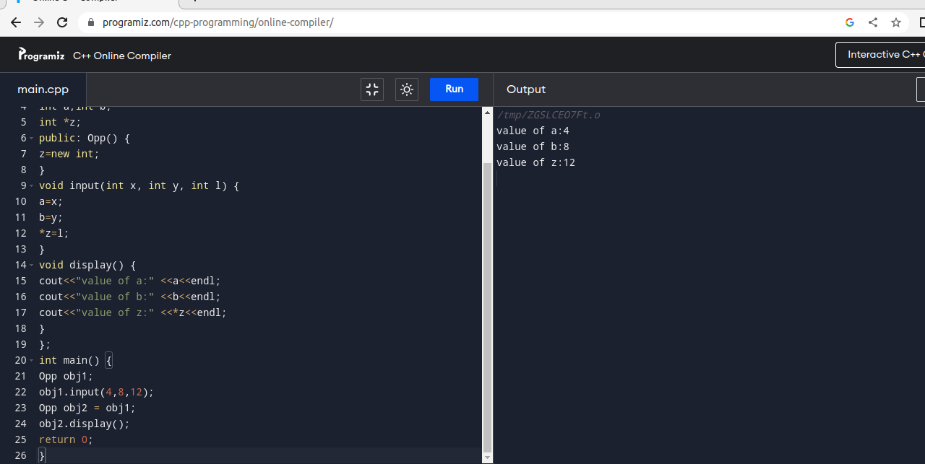

Example # 05
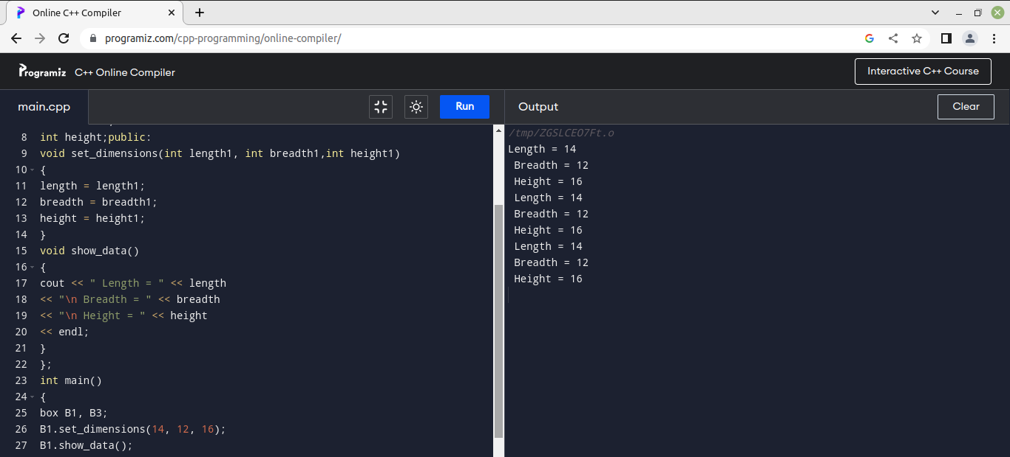

Example # 06

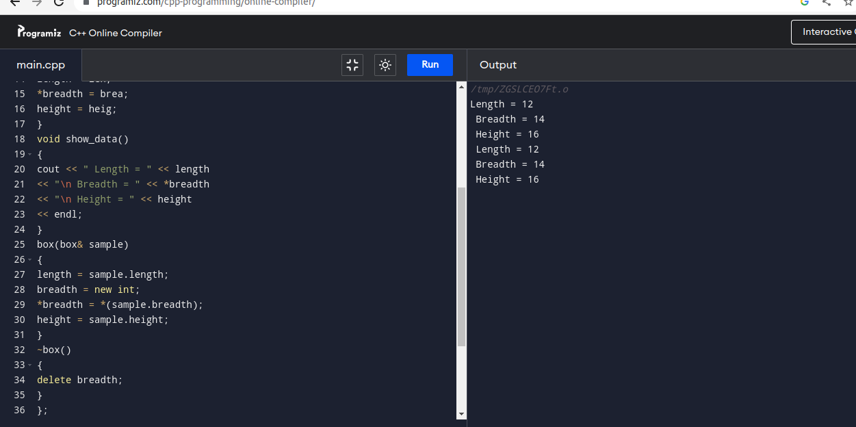

Example # 07
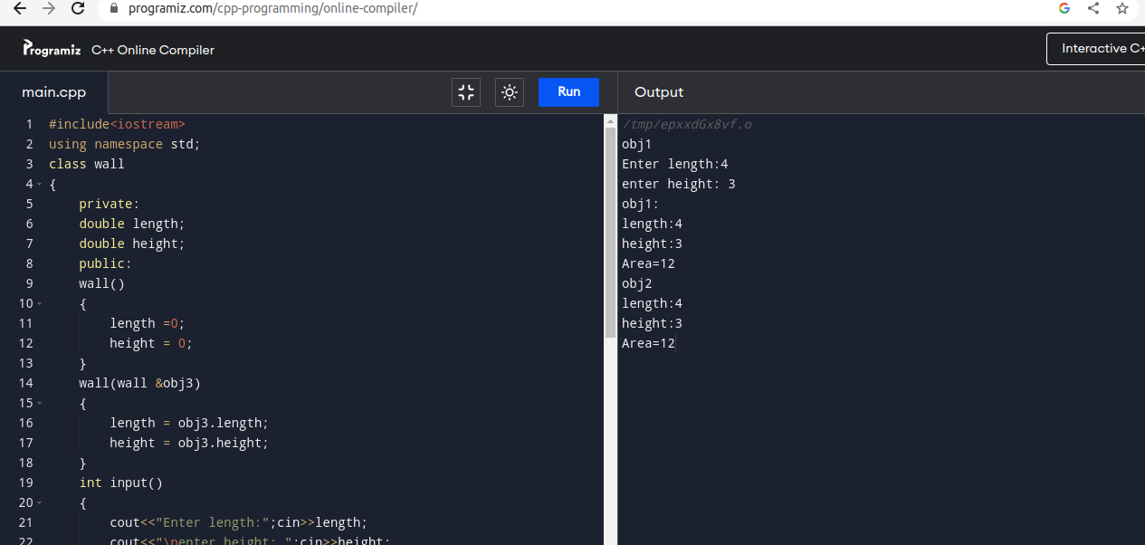
Example # 08
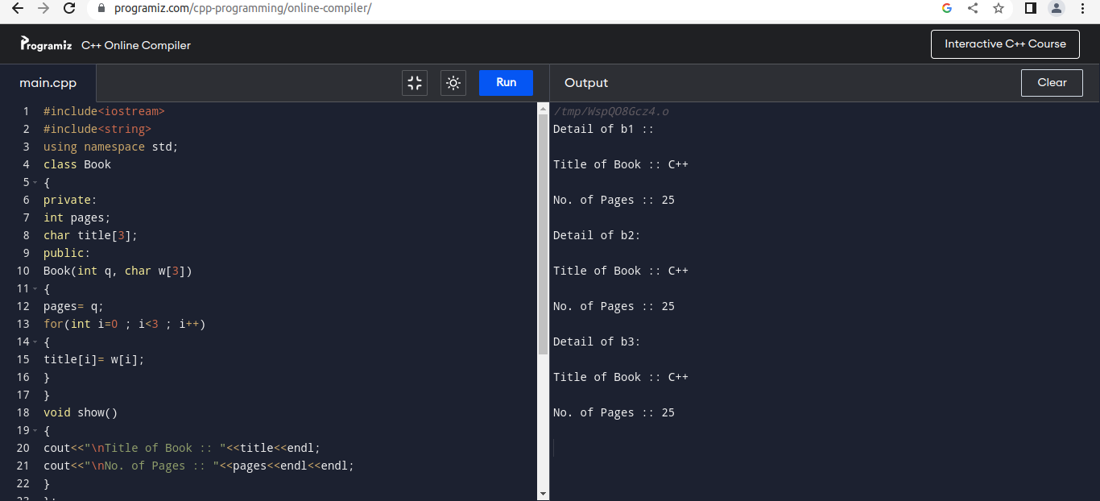
Review Questions
Question # 01
Solved all lab exercise questions from example 11.1 to 11.8 and check their output to your instructor??
Answer

All done

Question # 02
Show the output of the following program?

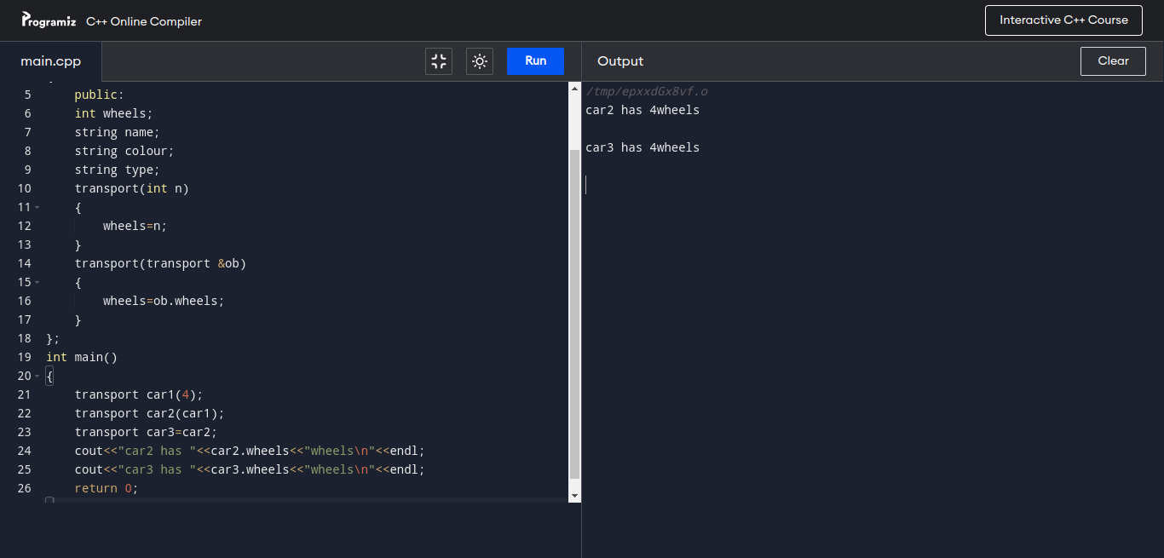
Answer
Question # 03
Write a C++ program to enter student details by passing parameters to constructor. By using copy
constructor make the program to provide the output?
Answer

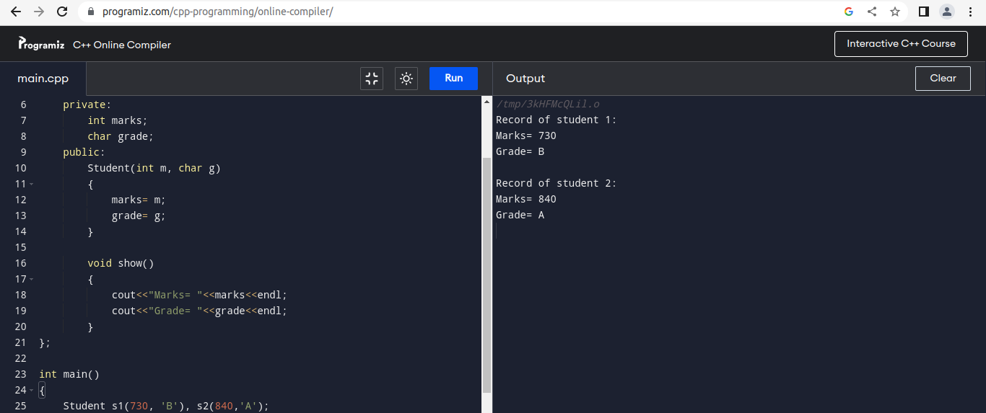
Question # 04
Design a system using a class called books with suitable member functions and constructors. Use
new operator in constructors to allocate memory space required?
Answer

